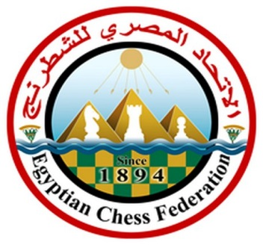

EVENT REGULATIONS
About holding the international youth chess blitz tournament
among children born in 2004 and younger
“HURGHADA YOUTH CHESS OPEN 2020 BLITZ”

8th of January 2020

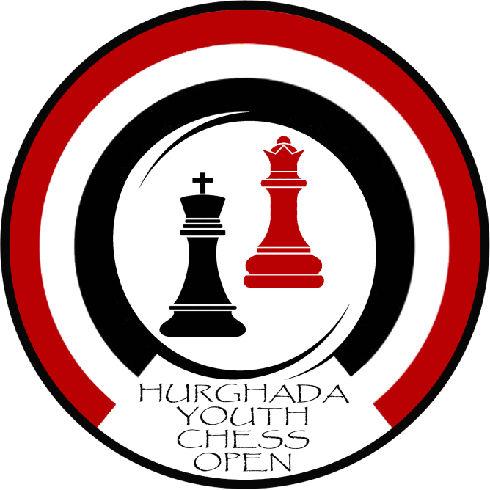

1. Goals and objectives of the competition
1.1. Chess promotion among boys and girls
1.2. Participants skills improvement
1.3. Chess promotion in Hurghada and other cities of Egypt
1.4. Gaining experience with chess players from different countries

2. Conducting organizations
2.1. Chess School “YS” Hurghada, Egypt
Owner & Tournament Director: Mr. Yuriy Solyanik
2.2. Hotel 5*Nubian Aqua Beach Resort Hurghada. General Manager: Mr. Amr Adel
2.3. Egyptian Chess Federation. President: Mr. Hesham El Gendi
Chief arbiter: Abdel Aziem, Ramadan (International Arbiter)
2.4. Technological organizer: Pedagogical Chess Union. Director Mr. Moiseev, Sergey S.

3. Dates and venue
3.1. The tournament will be held 8th January 2020.
3.2. Location: Egypt, Hurghada
Hotel 5* Nubia Aqua Beach Resort El Gouna road, 13 North Al Ahiaa.

4. Competitors
4.1. Children born in 2004 and younger who can play chess game with recording and chess clock are allowed to participate.
4.2. FIDE ID is required for each player.

5. Competition Program
5.1. Full-time registration and filling out forms of participants on January 2nd from 10:00 to 19:00 and 8th of January from 8:00 to 8:40 and from 16:00 to 16:40
5.2. Paring for the 1st round is held on 8th of January at 16:40
5.3. Tournament schedule:

Time / Date | January 5th
17:00 | Round 1
17:15 | Round 2
17:30 | Round 3
17:45 | Round 4
18:00 | Round 5
18:15 | Round 6
18:30 | Round 7
18:45 | Round 8
19:00 | Round 9
19:15 | Round 10
19:30 | Round 11

The tournament will be held in 11 rounds. The start of each round is according to the schedule.
5.4. Opening ceremony will be held on January 8th at 17:00.
5.5. Closing ceremony will be held on January 8th at 21:00.
5.6. The Swiss Manager program is used for the paring. The results are posted on
http://chess-results.com/
5.7. Time control is 3’+2”.
5.8. Competition is held according to the FIDE Chess Rules.
5.9. Tournament will be held with FIDE ratings calculations.
5.10. Participants are not allowed to be late on the game.
5.11. Official site of the tournament: egypt-chess.com

6. Evaluation of the results
6.1. Places are determined by the amount of points scored and in case of equality - by additional indicators:
a) Buchholz Tie-Break
b) Truncated Buchholz Tie-Break
c) Number of victories

In case of equality of all indicators for 2 participants, the prize place is determined by the decisive blitz game "Armageddon".
The draw will determine the choice of chess pieces.

7. Awards
7.1. The award ceremony is held at the venue of the tournament upon its completion.
7.2. Participants who take 1 - 3 places are awarded with cups, medals and diplomas.
7.3. The best girl is awarded with a cup, a medal, a diploma if the total number of girls in the tournament is more than 5 persons.
7.4. Participants from Egypt who show the best 3 results among their compatriots are awarded with cups, medals and diplomas, if the total number of Egyptian participants in the tournament is more than 10 persons.
The best girl from Egypt is awarded with a cup, a medal, a diploma if the total number of girls from Egypt in the tournament is more than 5 people.

8. Financing
8.1. The tournament fee is 20 USD
8.2. The fees are paid on site during the registration

9. Safety of the participants and accompanying guests
9.1. The tournament director and the “YS” chess school owner Mr. Yuriy Solyanik is entrusted to secure the safety of the competition in accordance with the International Sports Competition requirements and regulations.
9.2. A doctor on duty will be present during the competition for the participants of the tournament.

10. Contacts
Tournament Director: Mr. Yuriy Solyanik (Egypt, Hurghada)
Mobile/What’s Up/Viber
+201158826607
Co -organizers of the tournament: Mr. Igor Koptev (Russia, Krasnodar)
+79288480882
Mr. Sergey Moiseev (Russia, Moscow)
+79629982561
Registration and enquiries: Ms. Anna Gaidar
solyanik2002@gmail.com

